[ Insert official UPAEP logo ]
UPAEP · Decanato de Ingenierías
EVIDENCE — US11-T5
Show active alerts to the producer
SmartGreenAI: Cilantro Crop

1. Task information
Task ID | US11-T5
User Story | US-11 — Receive threshold alerts
Sprint | Sprint 3 (2026-10-12 – 2026-10-30)
Week | Week 2
Responsible | Jorge Velez Delgado
Peer reviewer | Alexis Enrique Valle Parra
Planned / actual hours | 2 h / 2 h
Completed on | October 23, 2026
Status | Done

2. Task description
Add an alerts panel and a top banner to the dashboard showing sensor, value, threshold and time in plain language, using the active alerts API (US11-T3). The panel refreshes every 30 s and the producer can acknowledge an alert.

3. Completion conditions
✓ Condition 1: Active alerts appear within 30 s of the measurement.
How it was verified: The alert appeared on the open dashboard 29 s after the measurement (the dashboard refreshes every 30 s).
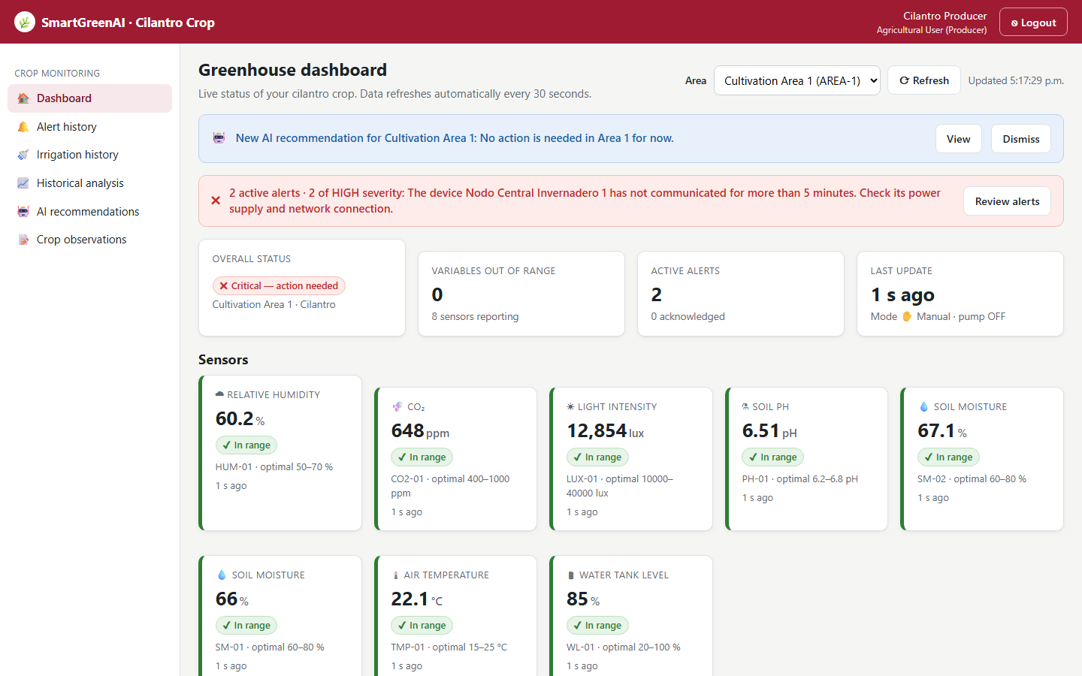
Figure US11-T5-1. Active alert on the dashboard 29 s after the measurement (no reload): top banner and alerts panel. (US11-T5_Show_Active_Alerts_Producer_1.png)
✓ Condition 2: The producer can acknowledge an alert.
How it was verified: The producer acknowledged the alert from the panel; the database stores who and when.
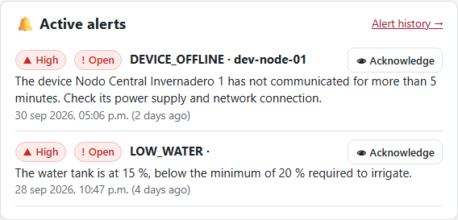
Figure US11-T5-2. Alerts panel: sensor, value, threshold and time in plain language, with the Acknowledge button. (US11-T5_Show_Active_Alerts_Producer_2.png)
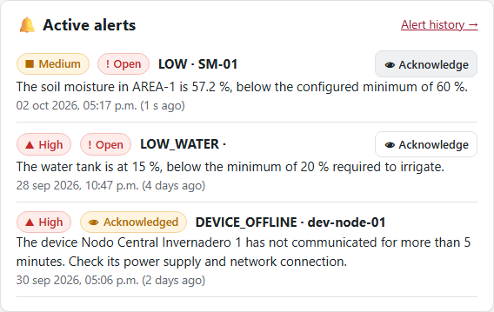
Figure US11-T5-3. After pressing Acknowledge: the alert is marked "Acknowledged". (US11-T5_Show_Active_Alerts_Producer_3.png)
Acknowledgement stored with user and time (1 rows; US11-T5_Show_Active_Alerts_Producer_4.csv)
id | status | message | acknowledged_by | acknowledged_at
alr-139f32664cbc | ACKNOWLEDGED | The soil moisture in AREA-1 is 57.28 %, below the configu… | producer@smartgreen.ai | 2026-09-29T04:37:53.531Z
SQL: SELECT a.id, a.status, a.message, u.email AS acknowledged_by, a.acknowledged_at FROM alerts a LEFT JOIN users u ON u.id = a.acknowledged_by WHERE a.sensor_id = 'SM-01' AND a.status = 'ACKNOWLEDGED' ORDER BY a.created_at DESC LIMIT 1
✓ Condition 3: The message can be understood by a non-technical user.
How it was verified: The message is plain language, for example: "The soil moisture in AREA-1 is 57.28 %, below the configured minimum of 60 %.". It names the variable, the area, the measured value and the configured limit, with severity and status shown as colour + icon + text.
server/src/modules/alerts/service.js — lines 22–33
const VARIABLE_LABEL = {
temperature: 'air temperature',
air_humidity: 'relative humidity',
soil_moisture: 'soil moisture',
light: 'light intensity',
co2: 'CO2 concentration',
water_level: 'water tank level',
ph: 'soil pH',
};
/**
* Classify severity from the deviation outside the threshold, expressed as a

✓ Condition 4: Evidence: Screenshots of the dashboard with an active alert and with the alert acknowledged.
How it was verified: Screenshots of the dashboard with an active alert and with the alert acknowledged (Figures 1–3).

4. Attached files
- US11-T5_Show_Active_Alerts_Producer_1.png
- US11-T5_Show_Active_Alerts_Producer_2.png
- US11-T5_Show_Active_Alerts_Producer_3.png
- US11-T5_Show_Active_Alerts_Producer_4.csv
- US11-T5_Show_Active_Alerts_Producer_5.sql

5. Traceability
Related requirements | FR-12, FR-13, FR-22
Implementation | producer-dashboard.js → renderBanner(), renderAlerts() (auto-refresh 30 s, acknowledge)
Verification | e2e/dashboard.spec.js (alerts panel)

6. Sign-off
Role | Name | Date | Signature
Responsible | Jorge Velez Delgado | October 23, 2026
Peer reviewer | Alexis Enrique Valle Parra | October 23, 2026
Product Owner acceptance | Alexis Enrique Valle Parra | October 23, 2026
Approval record: Daily Meeting 3 of Sprint 3 (Monday, October 26, 2026), team update, Jorge Velez Delgado: "Finished US11-T5, active alerts panel and banner (alerts appear within 30 s)." Daily Meeting 3 of Sprint 3 (Monday, October 26, 2026), Scrum board: "Tasks moved to Done last week: US11-T3, US11-T4, US11-T5, US12-T2, US13-T3, US15-T6, US15-T7, US16-T3, US16-T4, US17-T2, US19-T4, US19-T5, US19-T6."

